Context:

Sustainability

Decision Analysis: Precision Agriculture techniques for Tropical systems

Choose: location, technology with available data/references

Options: smallhoder farmers, tropics, economic factors

Crop or group of crops (monocrop)

Agoforestry?

Laser leveling-> too expensive? Promotes monoculture (not environmentally sound)

Frederic Schönbach, marina, sara, kent, grace

Topic: Precision Agriculture/Smart farming in tropics

Location and crop to decide

Mind Map

### Data available:

* Costs (China, [winterwheat](https://drive.google.com/file/d/1EYYhoa21MNA_LcSqGeyPUR2-94UGl3xp/view?usp=sharing))
* Economic benefits ([China, winter wheat](https://drive.google.com/file/d/1EYYhoa21MNA_LcSqGeyPUR2-94UGl3xp/view?usp=sharing))-> NDVI (Normalized Difference Vegetation Index), GUI (Growth Uniformity Index)-> (future year benefits)
* Benefit/cost ratio ([China, winter wheat](https://drive.google.com/file/d/1EYYhoa21MNA_LcSqGeyPUR2-94UGl3xp/view?usp=sharing))-> exceeded baseline by 10%
* Crop yield (Eastern [Afghanistan](https://drive.google.com/file/d/1hECherYLOOf7ku7yLh2VdQh2_wsRpgY8/view?usp=sharing)) -> yield increased by 21%, 40%, and 38% wheat, corn, and eggplant

->(Rice-wheat [Northwest India](https://drive.google.com/file/d/1921TWo76tej9OxVR6hCPfNHxUwOlmuhU/view?usp=sharing))-> increased yield by 7% in rice; increased by 6.7% in Haryana and 8.8% in Punjab for wheat; translates to USD 138 ha-1 yr-1 additional benefit per farmer. Adopting LLL, even in 50% of the area under rice-wheat system in the Haryana and Punjab states can provide additional production of 699 million kg of rice and 987 million kg of wheat, amounting to USD 385 million/yr.

* Water efficiency (Eastern [Afghanistan](https://drive.google.com/file/d/1hECherYLOOf7ku7yLh2VdQh2_wsRpgY8/view?usp=sharing)) -> water demand reduced by 21%, 27%, and 17% for wheat, corn, and eggplant
* Water productivity Eastern [Afghanistan](https://drive.google.com/file/d/1hECherYLOOf7ku7yLh2VdQh2_wsRpgY8/view?usp=sharing))-> increased by 39%, 53%, and 37% for wheat, corn, and eggplant
* Groundwater use ([Punjab, Pakistan](https://drive.google.com/file/d/1fdPDBgxOeaVL5H1W-WXuGhMAYrUbp5Ij/view?usp=sharing))- reduced groundwater use by about 23%.
* Irrigation time (rice-wheat, [Northwest India](https://drive.google.com/file/d/1921TWo76tej9OxVR6hCPfNHxUwOlmuhU/view?usp=sharing))->reduced irrigation time by 47-69 h/ha per season in rice; 10-12 h/ha per season reduction in wheat. Savings in irrigation

time reduced the number of operation of tube wells for pumping water= savings of 558-762 kWh of electricity ha-1 yr-1 or 300-410 litres of diesel ha-1 yr-1.

* Environmental footprint (rice-wheat, [Northwest India](https://drive.google.com/file/d/1921TWo76tej9OxVR6hCPfNHxUwOlmuhU/view?usp=sharing)): savings of 558-762 kWh of electricity ha-1 yr-1 or 300-410 litres of diesel ha-1 yr-1 translates to reduced environmental footprint.
* Factors affecting adoption in Haryana, India (rice-[wheat systems](https://drive.google.com/file/d/1bwS57KgsQO7BxZwHoBAWTCUtCJ4Yt5Mc/view?usp=sharing))-> *farm size* (larger farms more likely to adopt). Information about technology through farmer-to-farmer communication and through private traders, *participation in agricultural training* and *membership in local agricultural institutions* increased both the likelihood and the intensity of adoption. There is negative association between land holdings and the proportion of laser-leveled land. Conclusion: *closer collaboration* among the various stakeholders, to promote *farmer-to-farmer communication* through i*ncreased participation in local institutions* and increase the rate of adoption
* Scalability (rice-wheat, [Northwest India](https://drive.google.com/file/d/1921TWo76tej9OxVR6hCPfNHxUwOlmuhU/view?usp=sharing)): LLL is a scale neutral technology i.e., not biased towards large farmers
* Key factors affecting speed of adoption ([Punjab, Pakistan](https://drive.google.com/file/d/1fdPDBgxOeaVL5H1W-WXuGhMAYrUbp5Ij/view?usp=sharing)): strong legal land rights, access to information about the technology, and exposure to the technology. Long distance to rental market deaccelerates the speed of adoption (logistics). Conclusion: improving access to extension services, exposure to innovation, and legal land rights can enhance the adoption and diffusion of the technology.

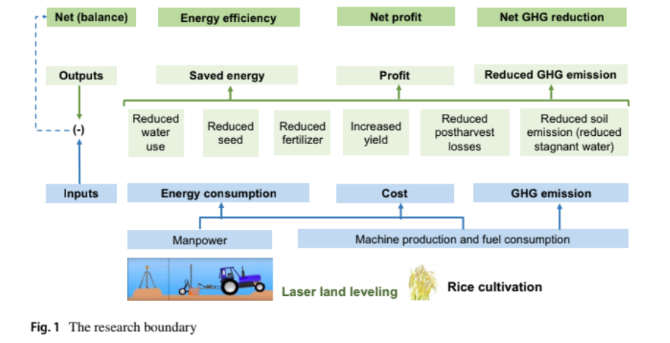

Source: https://drive.google.com/file/d/1Lj4Ij-4uyMEdVQpIT-gbcKnMMJLrs_PZ/view?usp=sharing

Workflow chart for groups (track progress)- check the tool to use- schedules

Zoom/googlemeet?

Microsoft teams

Things to talk about:

Which perspective to assess from: farmer

Location: Asia → somewhere where there is water scarcity (Pakistan maybe?)

Tech: Laser leveling

Decision we want to analize: Is laser leveling a good tool for my XXX (rice?)**farm**

### Variables to take into account on our model of decision analysis

|  |  |  |
| --- | --- | --- |
| Economic | Ecologic | Social |
| Technology price  Revenue potential → harvest increase?  Amount of agronomic input | Risk of intensified systems (monoculture, reduced biodiversity, landscape degradation → land sharing or sparing approch)  Water use reduction | Land rights  Small-Farmers organisations → cooperatives? |

Edit the system models in this link: <https://tinyurl.com/AdoptionLaserLeveling>

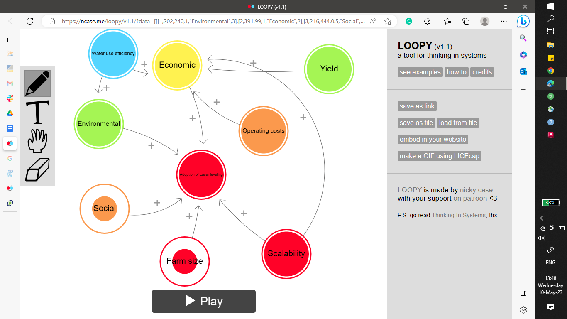

Tasks:

Read more into the aspects

Choose where to focus-> which approach would make sense?

Ask Frederrick for the old project-> what are the things we should look at? Targeting

**What do farmers value the most?**

Profit- logistics, inputs, capital cost, operating cost, ROI

Distance (location of rental company)

**Background about laser levelling**: this is already an old technology being used in Europe, US, etc. in largescale crop lands that require even fields. In Asia, not that much adopted because lands are mostly not yet consolidated (farm ownership is small per family). Capital investment is huge issue (farmers are not rich enough to buy technology). A business model being suggested by IRRI Postharvest and Mechanization department can be tested in our project: if the business model will be acceptable from farmer’s side.

Laser levelling technology being proposed:

Drag bucket type as seen in <http://www.knowledgebank.irri.org/images/docs/training-manual-laser-leveling.pdf>

**Update from Rice (Land Use Systems lecture):**

Specific system: **Lowland irrigated rice**-> most important rice system type, this is where laser levelling is applicable and important. Slight changes in uniformity of field can lead to water use inefficiency and presence of weeds (in areas not submerged in water)

Probable locations of interest: **areas with irrigated flat lands in Asia**, etc. (must have water supply all year round)-> possible: Thailand (great adoption, supportive government, monarchy so farmers might not have that much freedom to choose), Vietnam (deployment is very easy, communist government, supportive of technology but farmers do not have much freedom to choose to adopt or not to), Cambodia (quite conservative and skeptical about any tech, very early stages of mechanization), Philippines (lands are still not consolidated but are employing combine harvesters already)

We should understand the **drivers and determinants that drive change** (adoption of technology)…

